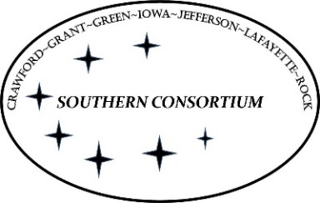

**AGENT Reminders July 11, 2024**

**FoodShare**

* When clients have exhausted their 3 TLBs do not tell them to call FSET to get their Foodshare benefits reinstated. If the client is no longer eligible for FS, they are no longer eligible for FSET.

Eligibility may be regained by completing one of the following:

* + Providing verification that the FoodShare work requirement was met for any 30 consecutive day period following the loss of FoodShare eligibility
  + Verifying that the FoodShare work requirement will be met within 30 days of the new filing date. The FoodShare work requirement can be met by completing one of the following:
    - Working a minimum of 80 hours in the 30-day period
    - Participating in and complying with requirements of an allowable work program for at least 80 hours in the 30-day period
      * FoodShare eligibility is a required prerequisite to FSET enrollment, so an ABAWD can't regain eligibility through FSET participation after FoodShare closes.
      * If an ABAWD is FoodShare eligible at the time of the FSET referral and enrollment, the ABAWD can participate in FSET and be expected to meet the FoodShare work requirement.
    - A combination of work and participation in an allowable work program for a minimum of 80 hours in the 30-day period
  + Providing verification of a current exemption from the FoodShare work requirement at the time of the application
  + Providing verification of an exemption that removes one or more TLBs
  + The three-year clock expires

**EBD/LTC**

* In the past REP screen for Guardian’s and POA’s were on the same screen, the system has been updated so we can enter a Guardian on a Guardian screen and a POA on a POA screen, **BUT** when the system updated it defaulted all premade REP screen for Guardian’s and POA’s to update as Guardian, but it does give us a yellow banner, we need to **STOP** and look at the verification in ECF (LEGAL), if the verification is for Guardian, then GREAT, press enter **BUT** if the verification is for POA, we need to remove the Guardian screen and build a POA screen. This does not change any of the rules we have with our REP flow chart.

**General**

* When processing documents on a case with the wrong document code, workers should be changing the code to the correct code prior to moving to ECF.