Southern Call Center Supervisor Schedule for June 2023
Open M-T-W-F 8:30-4 and TH 11:00-4
Genesys Admins/Superheroes: Cece Fishnick XGT008, Ali McCalmont XRO646, Mendy Chesebro XCR048
Monday | Tuesday | Wednesday | Thursday | Friday
 | 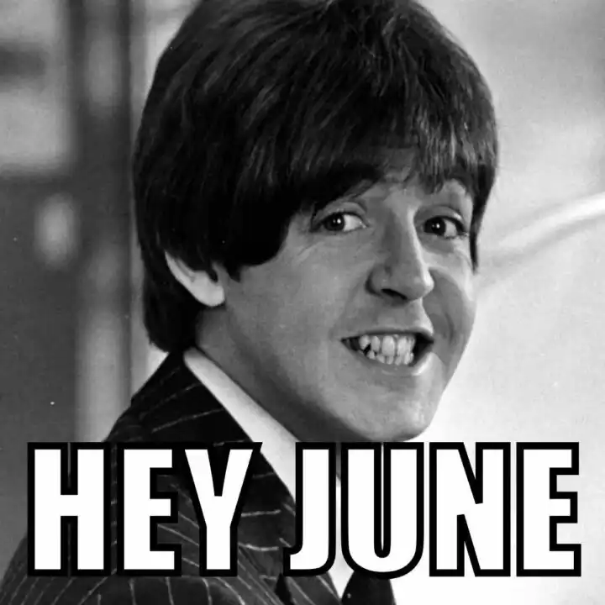 |  | 1  C=0 GT=5  GN=4 I=1 + (1 from 11-1)  J=6 + (1 from 11-1) L=1  R=18  Cece | 2  C=2 GT=4  GN=3 I=2  J=7 L=1  R=18  Ali
5  C=2 GT=5  GN=3 I=2  J=7 L=2  R=19  Mendy | 6  C=2 GT=4  GN=3 I=2  J=7 L=1  R=18  Cece | 7  C=2 GT=5  GN=3 I=2  J=7 L=2  R=19  Ali – Sups mtg 9a-12p | 8  C=0 GT=5  GN=4 I=1 + (1 from 11-1)  J=6 + (1 from 11-1) L=1  R=18  Mendy | 9  C=2 GT=4  GN=3 I=2  J=7 L=1  R=18  Cece
12  C=2 GT=5  GN=3 I=2  J=7 L=2  R=19  Ali | 13  C=2 GT=4  GN=3 I=2  J=7 L=1  R=18  Mendy | 14  C=2 GT=5  GN=3 I=2  J=7 L=2  R=19  Cece | 15  C=0 GT=5  GN=4 I=1 + (1 from 11-1)  J=6 + (1 from 11-1) L=1  R=18  Ali | 16  C=2 GT=4  GN=3 I=2  J=7 L=1  R=18  Mendy
19  C=2 GT=5  GN=3 I=2  J=7 L=2  R=19  Cece | 20  C=2 GT=4  GN=3 I=2  J=7 L=1  R=18  Mendy | 21  C=2 GT=5  GN=3 I=2  J=7 L=2  R=19  Ali | 22  C=0 GT=5  GN=4 I=1 + (1 from 11-1)  J=6 + (1 from 11-1) L=1  R=18  Cece | 23  C=2 GT=4  GN=3 I=2  J=7 L=1  R=18  Ali
26  C=2 GT=5  GN=3 I=2  J=7 L=2  R=19  Mendy | 27  C=2 GT=4  GN=3 I=2  J=7 L=1  R=18  Ali | 28  C=2 GT=5  GN=3 I=2  J=7 L=2  R=19  Mendy | 29  C=0 GT=5  GN=4 I=1 + (1 from 11-1)  J=6 + (1 from 11-1) L=1  R=18  Cece | 30  C=2 GT=4  GN=3 I=2  J=7 L=1  R=18  Ali
MC 5/24/2023

